Statistical Significance

I was unable to find major statistical significance in the pairwise testing of the different muscle groups against these stratifications. Some of the stratifications that I used were: attending vs. nonattending, lead vs. rampart, case length differences, and gender differences. In all these cases, there were some statistically significant differences, but most weren’t. This showcases that generally there weren’t major differences in the sum of duration in risk positions for these different population groups. There could be more differences when analyzing larger samples, but from this study, we can’t conclude there to be statistically significant differences in all cases. We can only showcase that there was a difference based on the box plots that I will reference along with the respective values as we have looked at before.

# Joint Angles and Kinematics Data

* Stratify by Gender:
  + 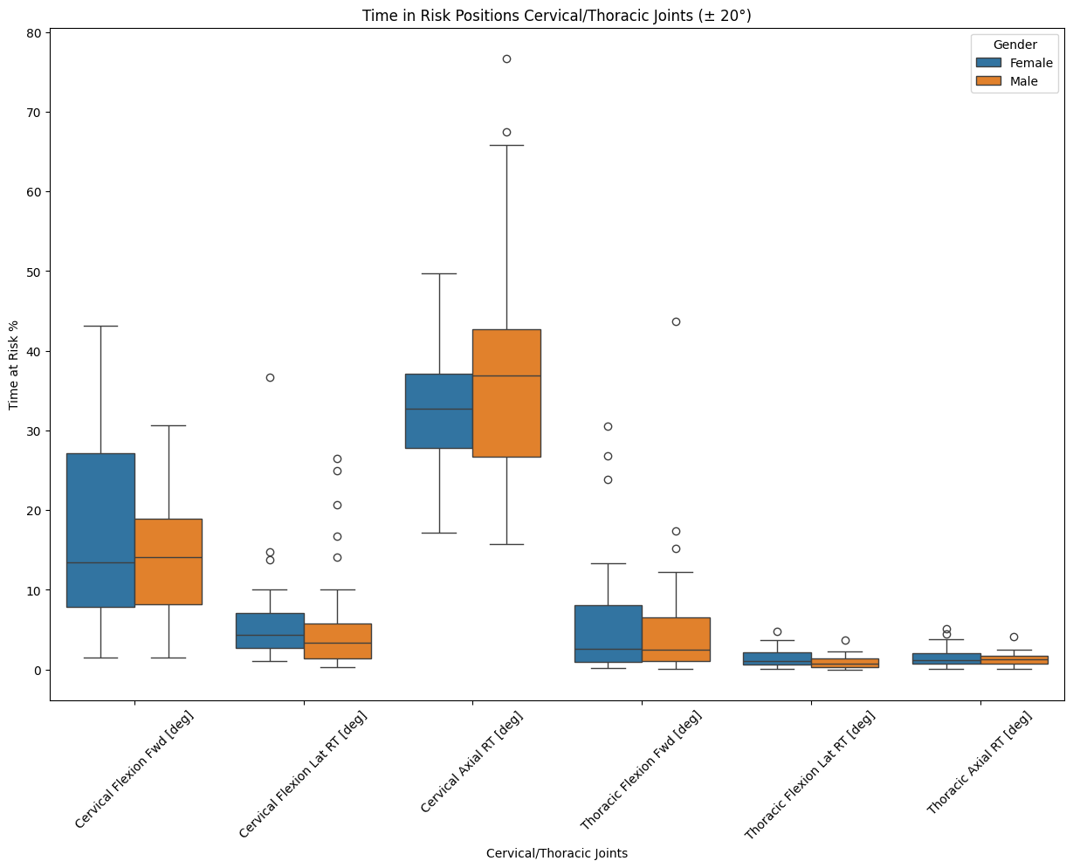
  + 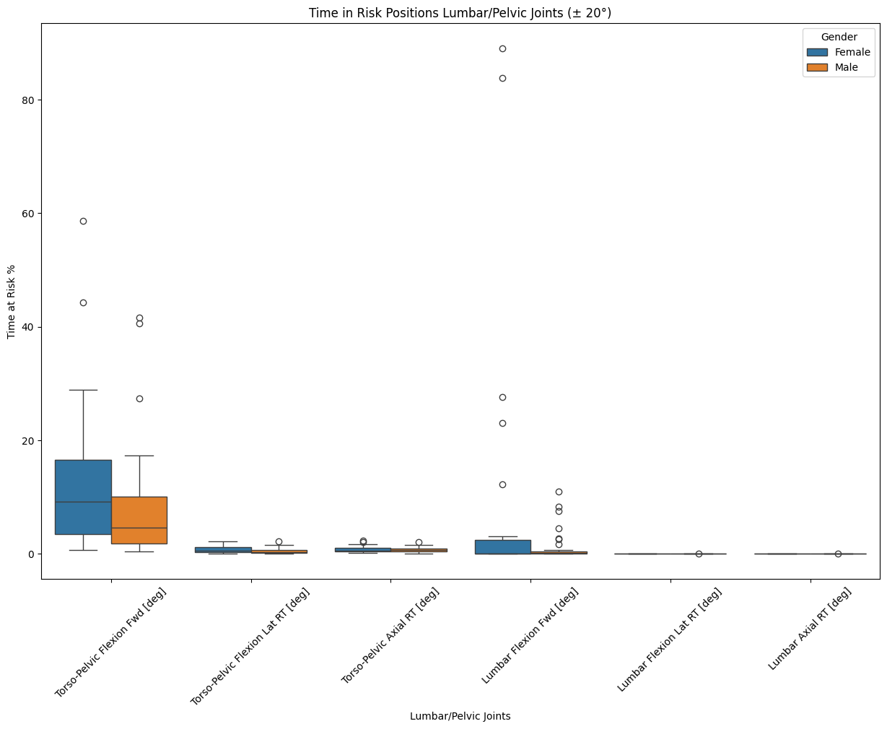
    - 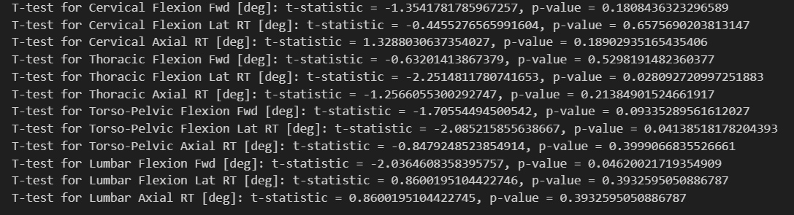
* Stratify by Attending vs. Nonattending:
  + 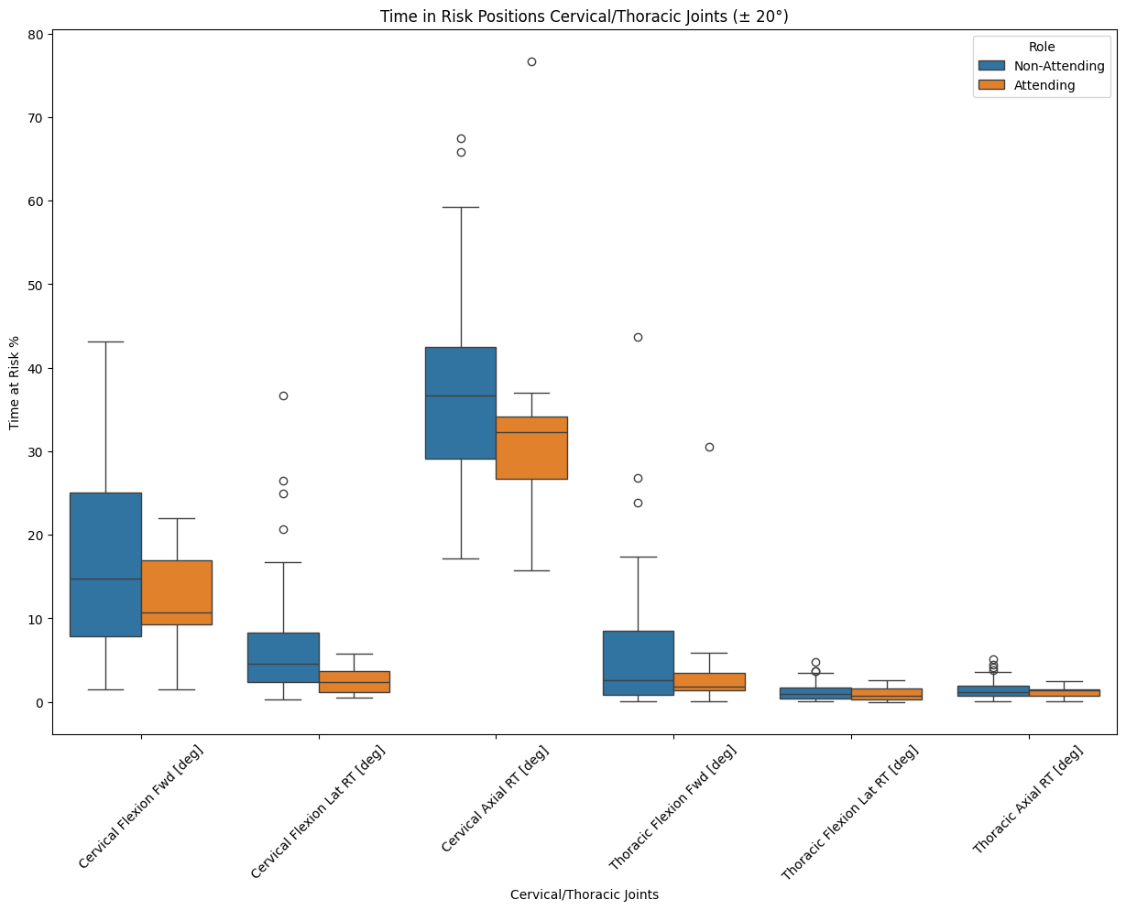
  + 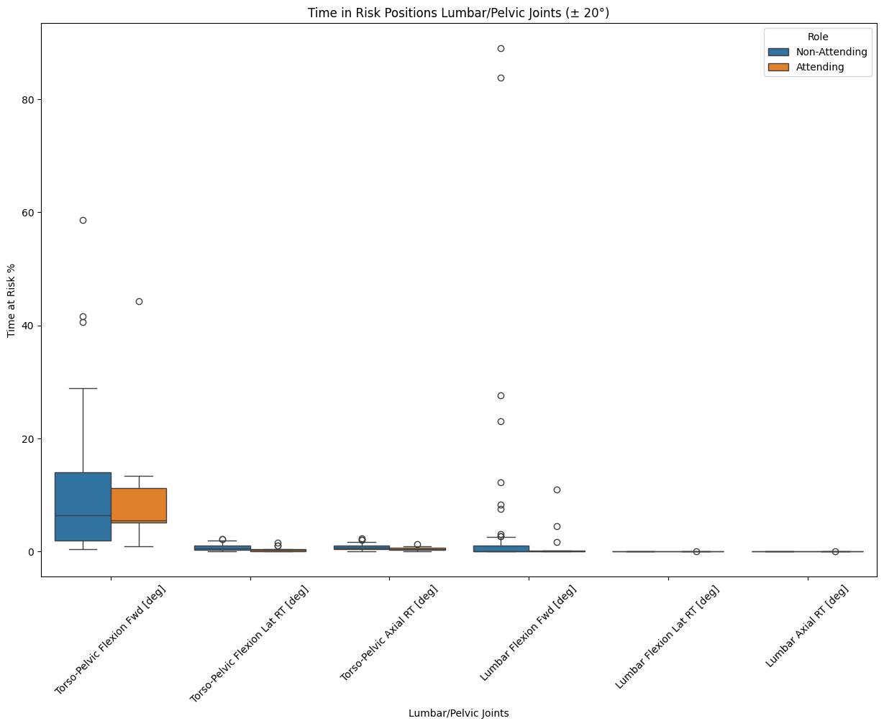
    - 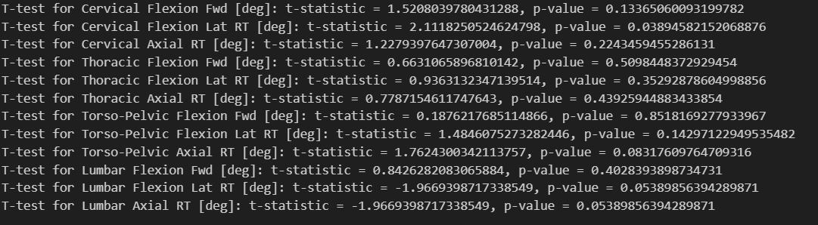
* Stratify by Lead vs. Rampart:
  + 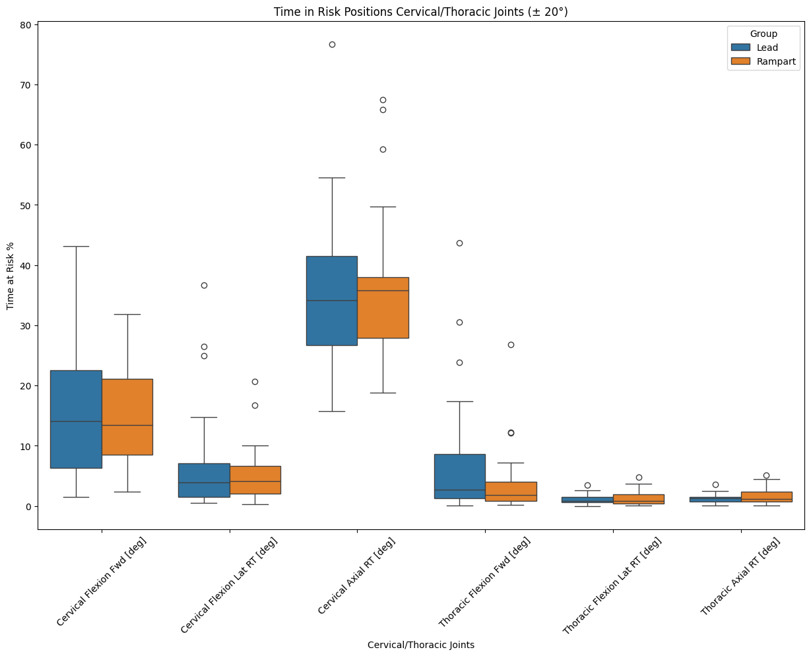
  + 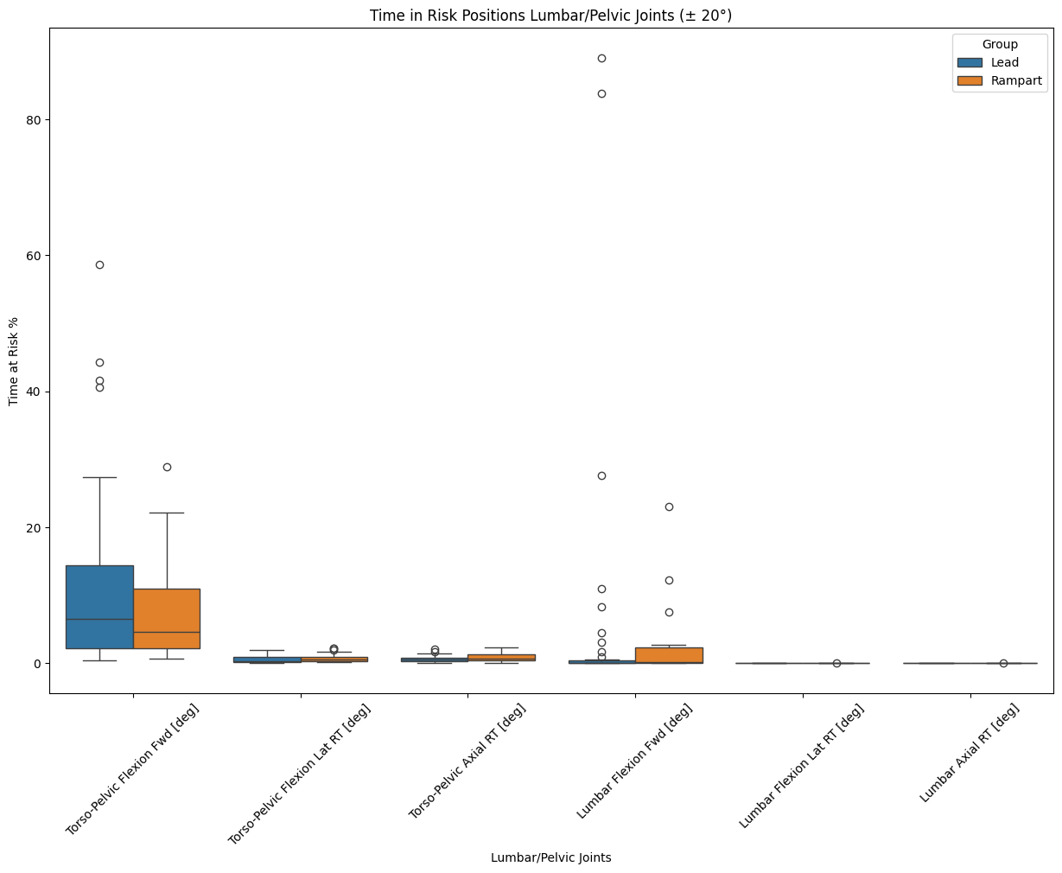
    - 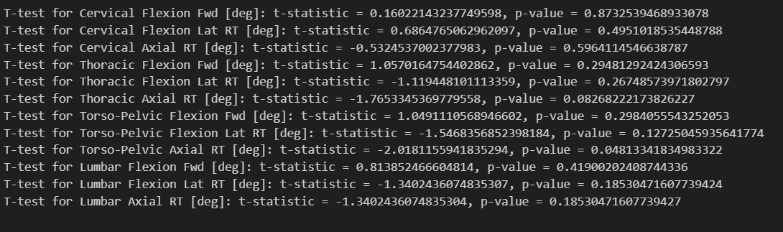
* Stratify by Case Length:
  + 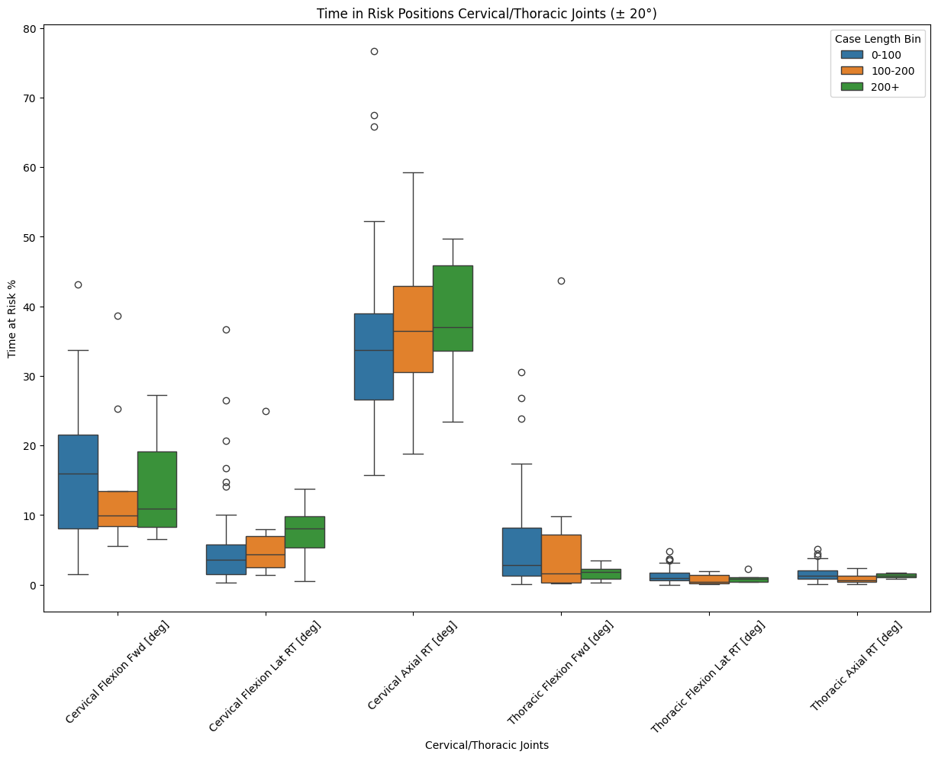
  + 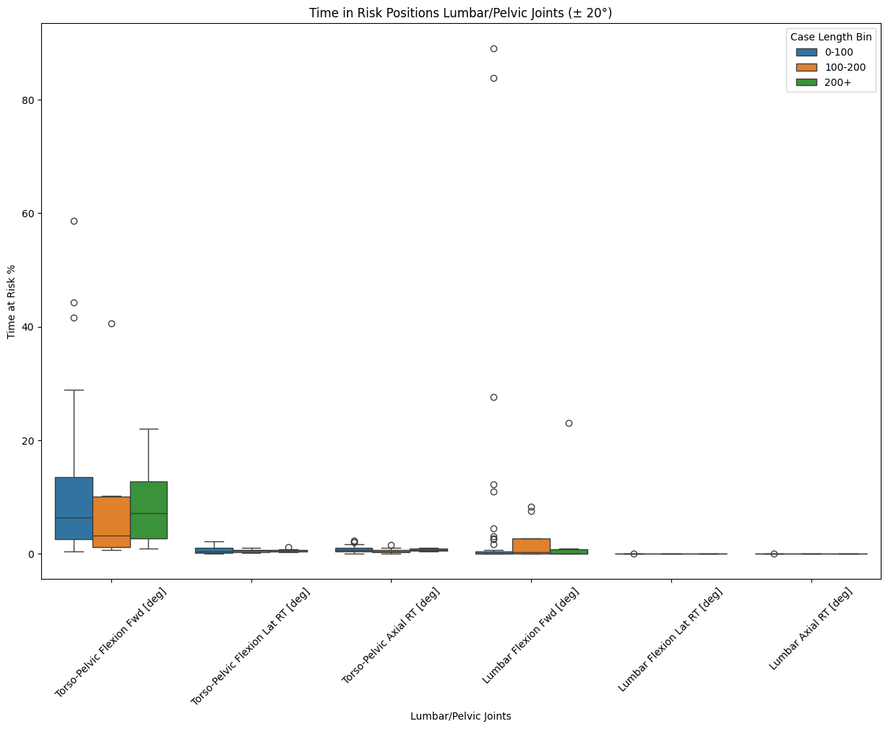
    - No significant differences in this stratification.
  + 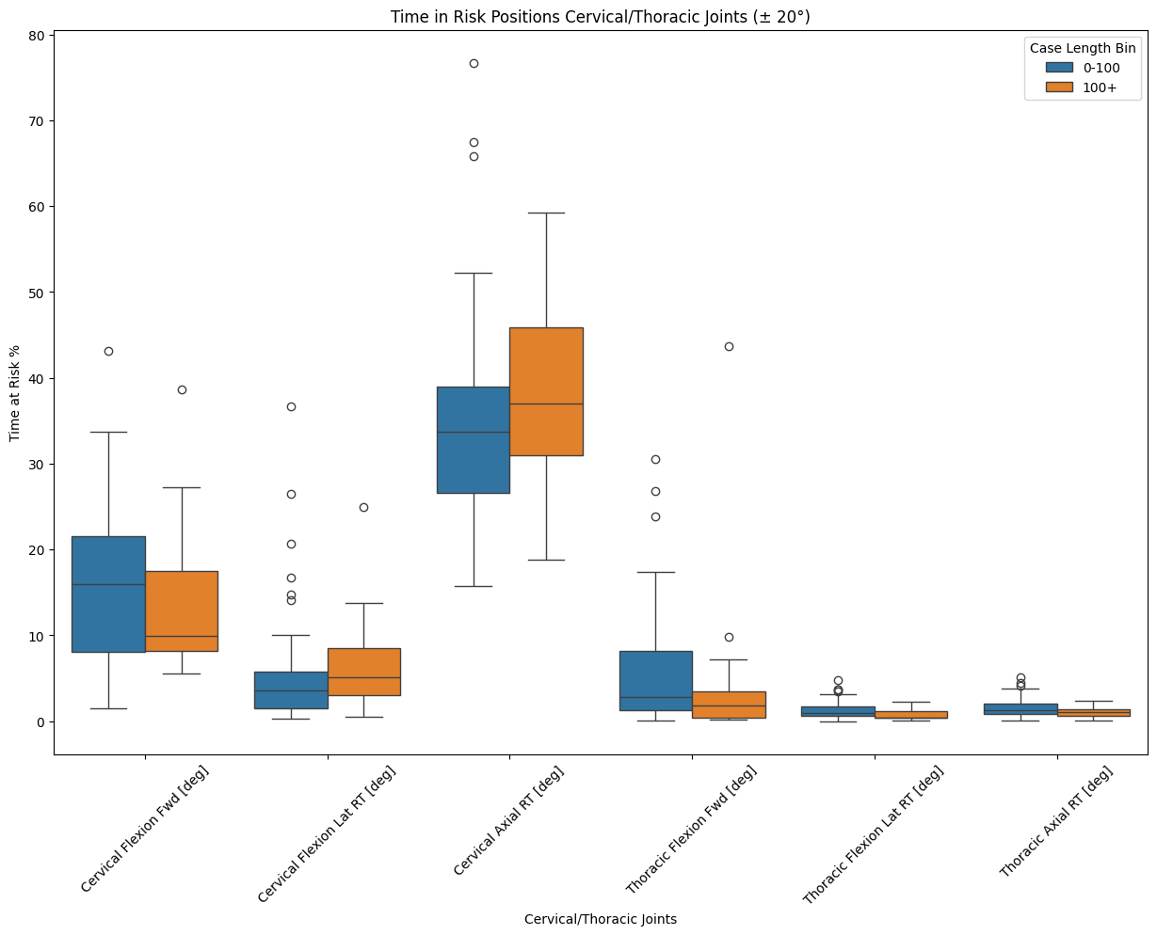
  + 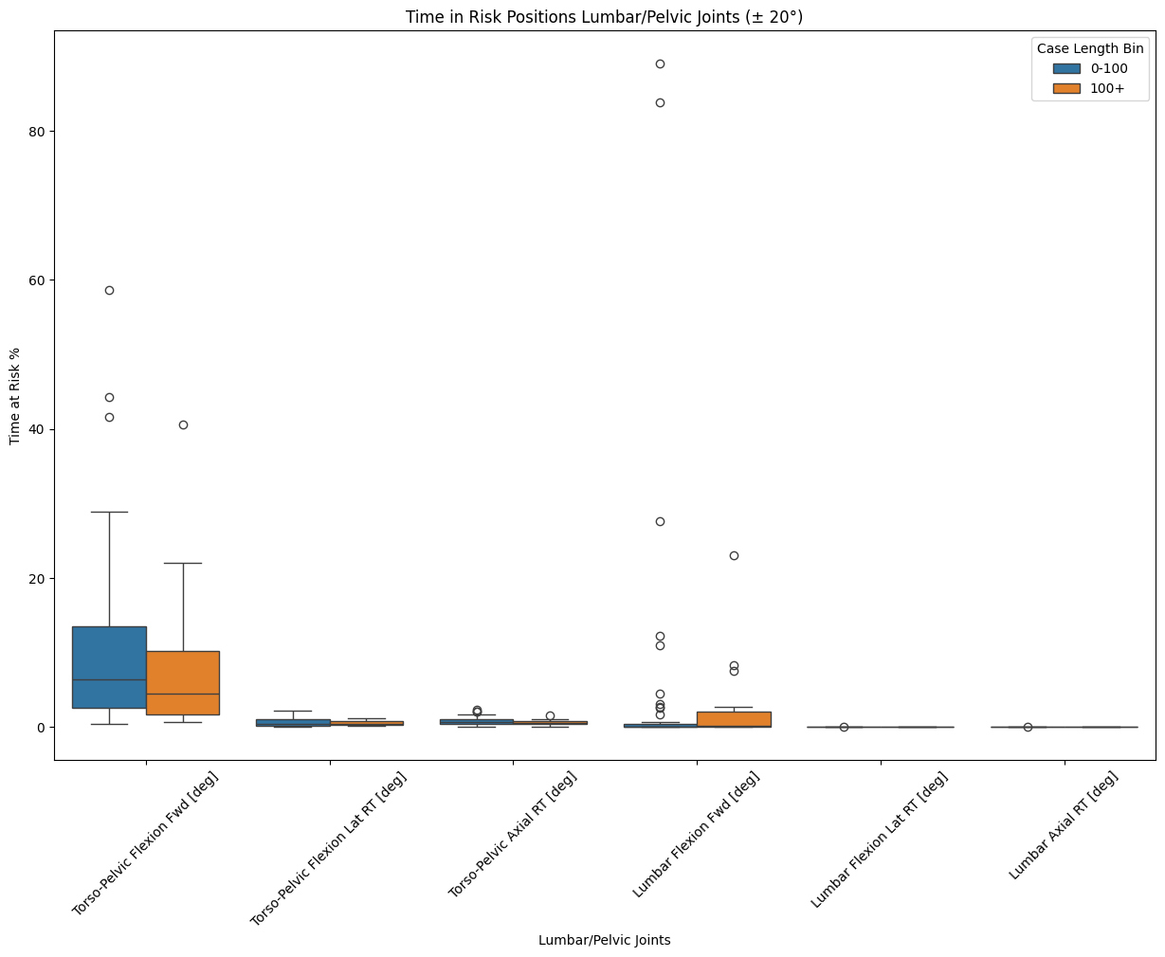
    - There were also no statistically significant results for this method of looking at the time labels in the joint sum of duration data.

# EMG Data

* Stratify by Gender:
  + 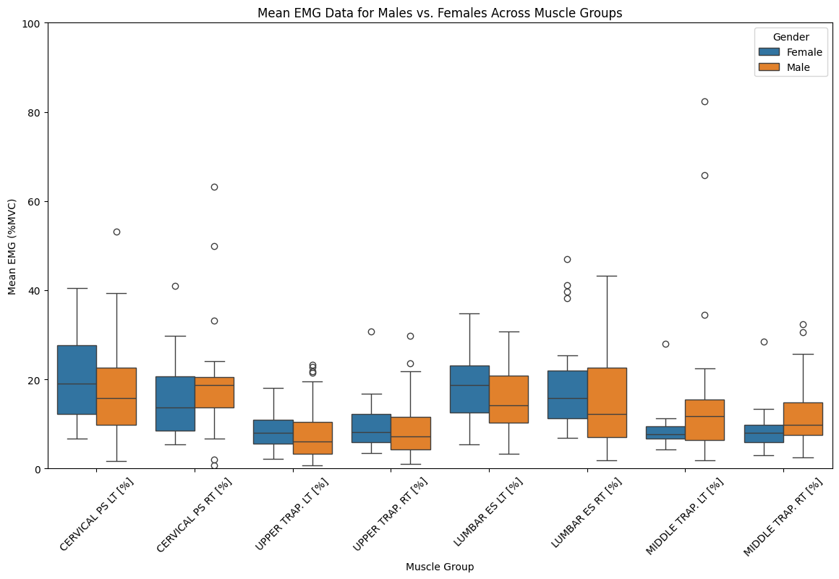
  + 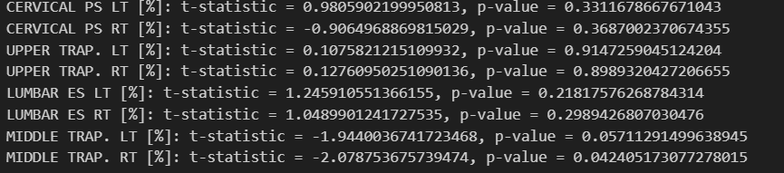
  + 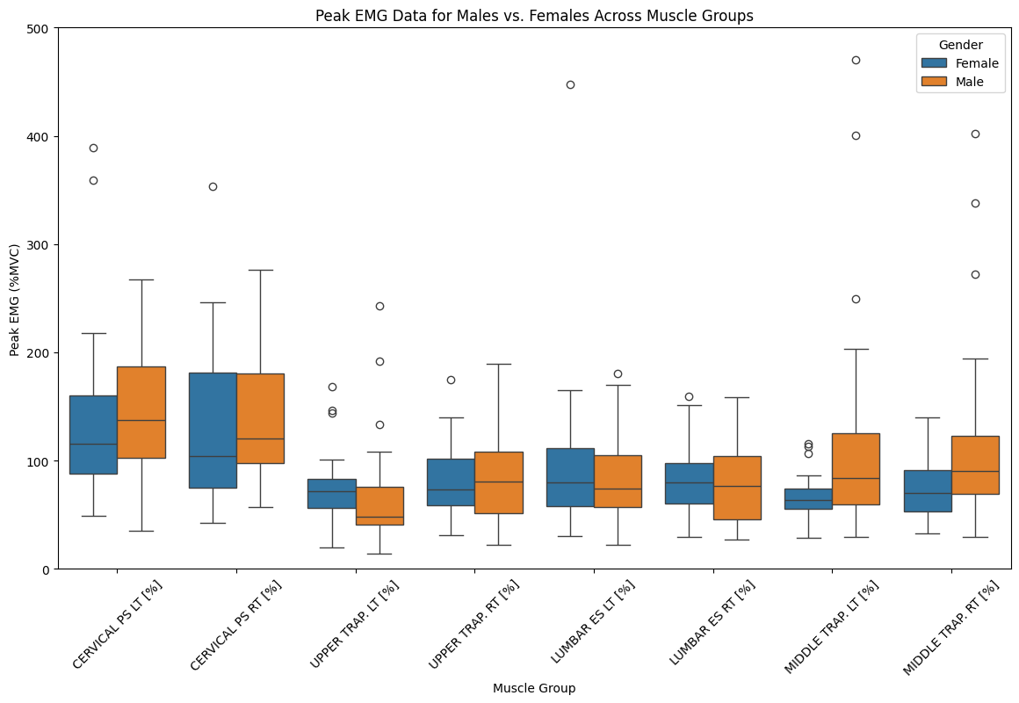
  + 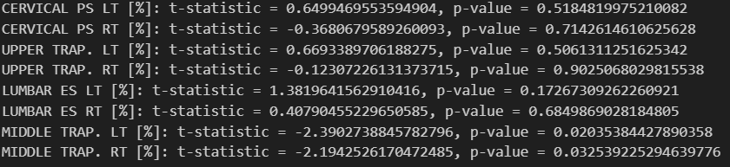
  + 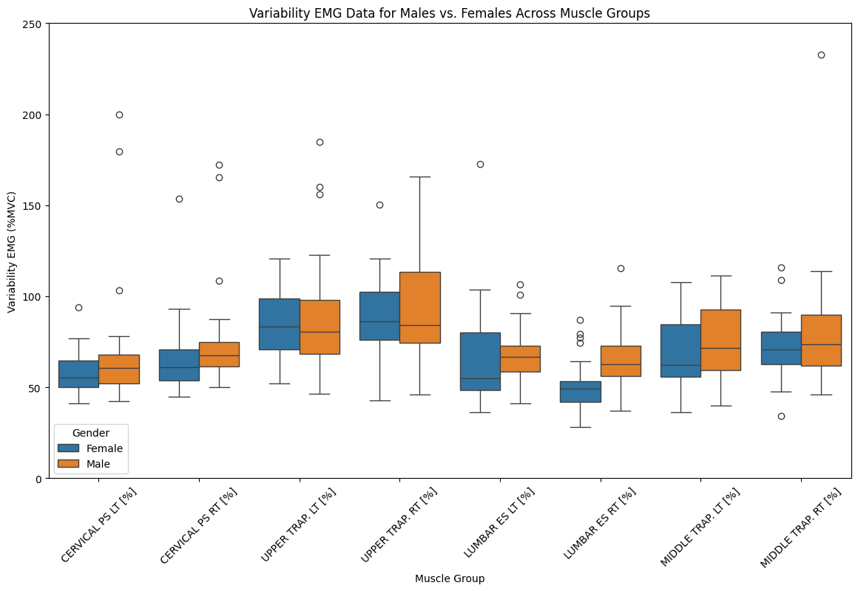
  + 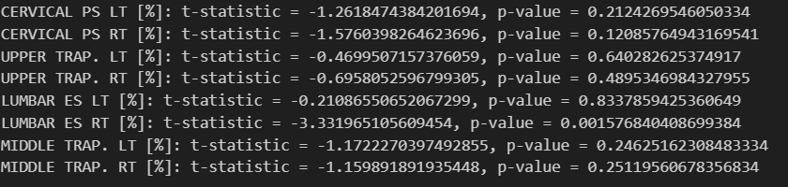
* Stratify by Attending vs. Nonattending:
  + 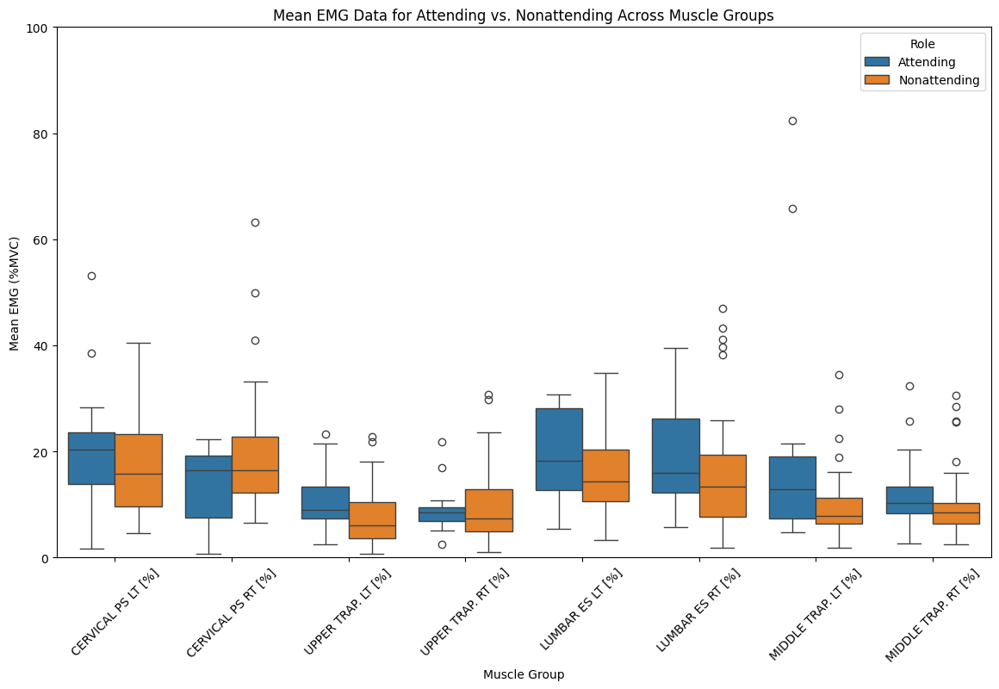
  + 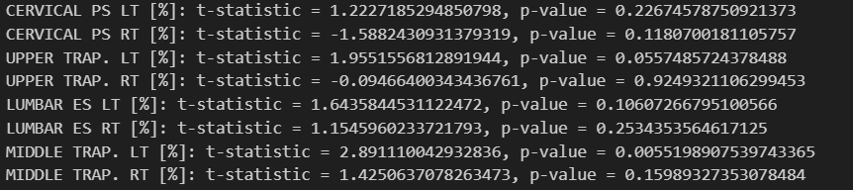
  + 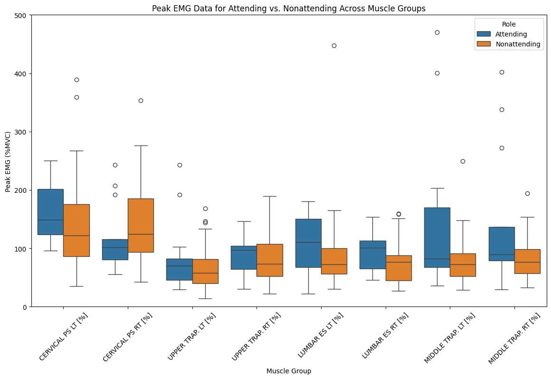
  + 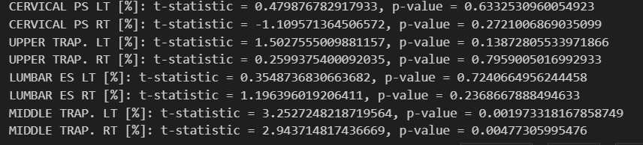
  + 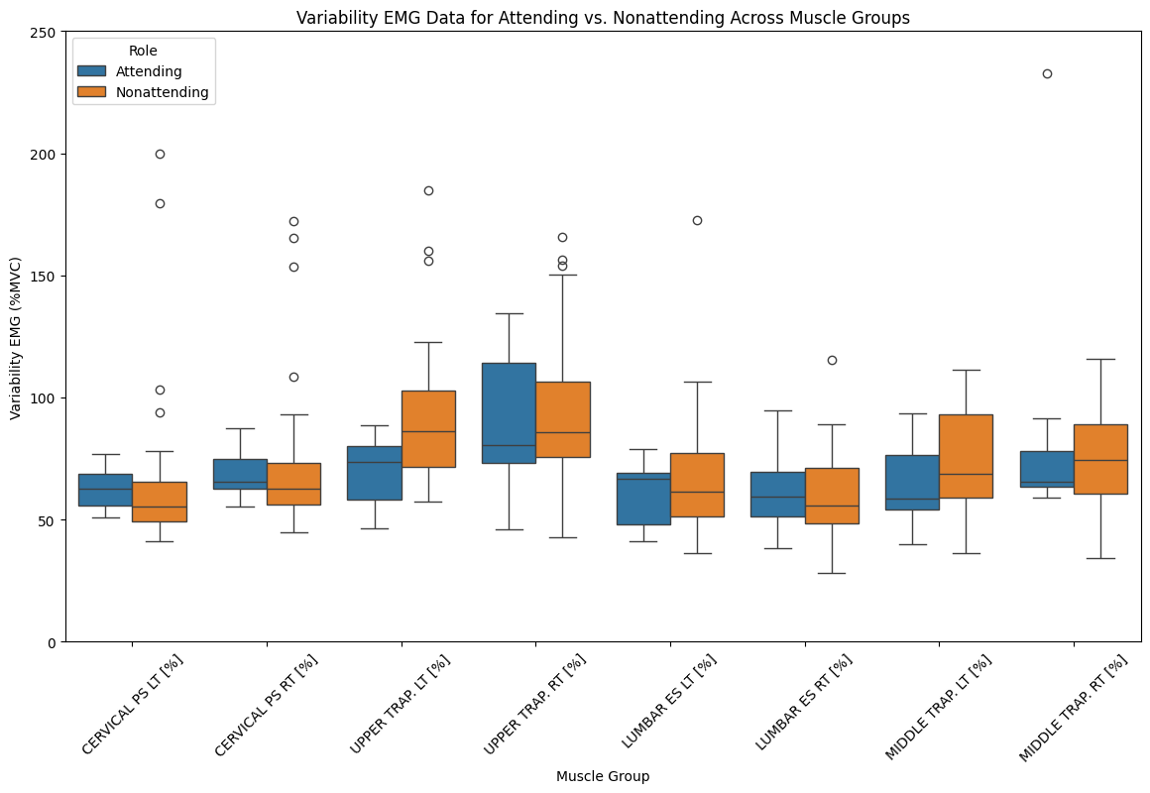
  + 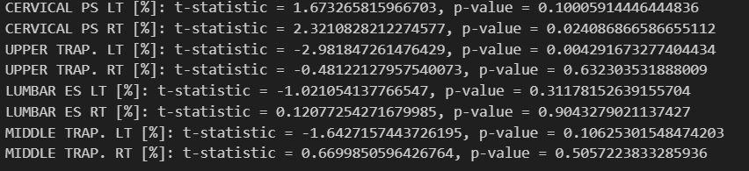
* Stratify by Lead vs. Rampart:
  + 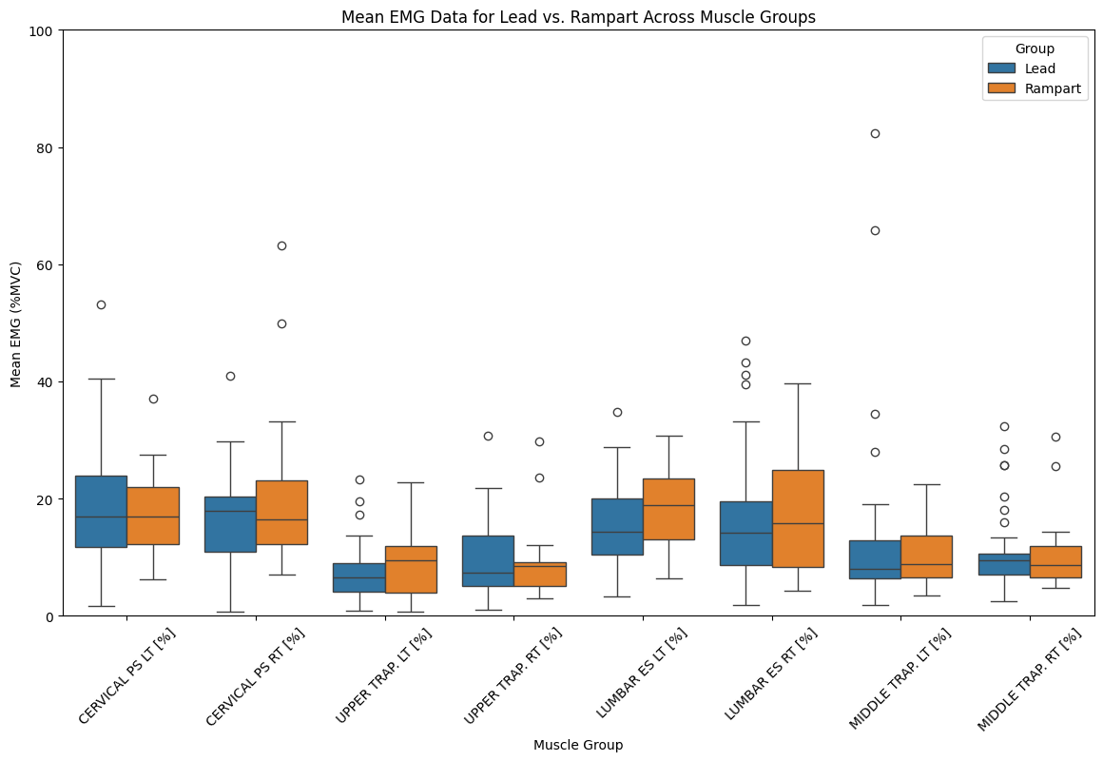
  + 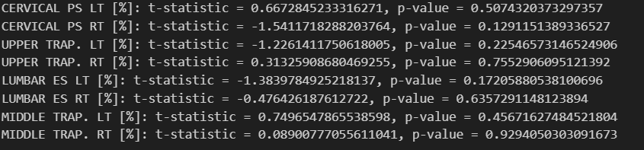
  + 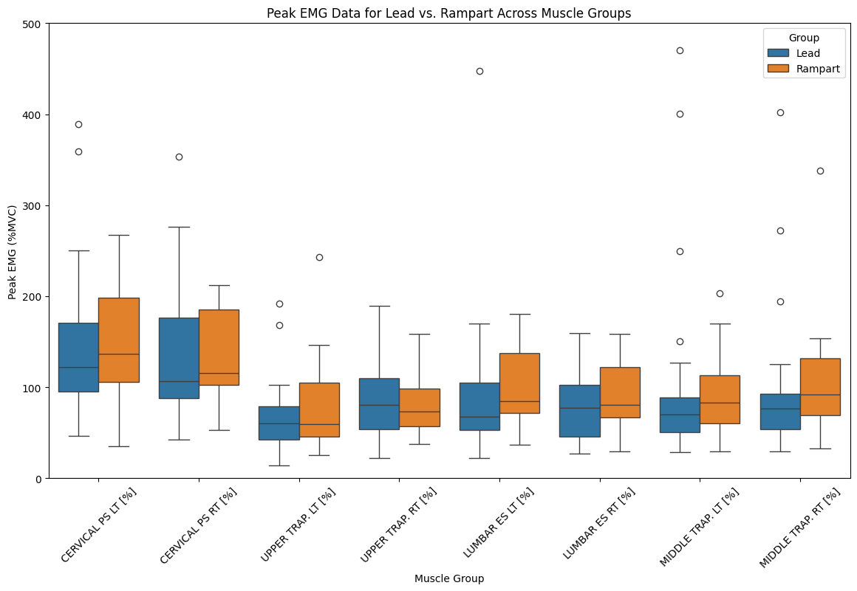
  + 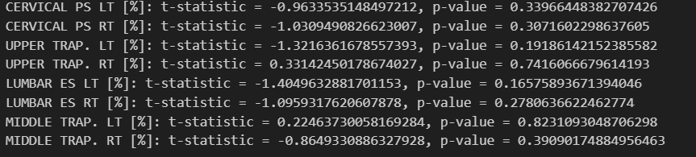
  + 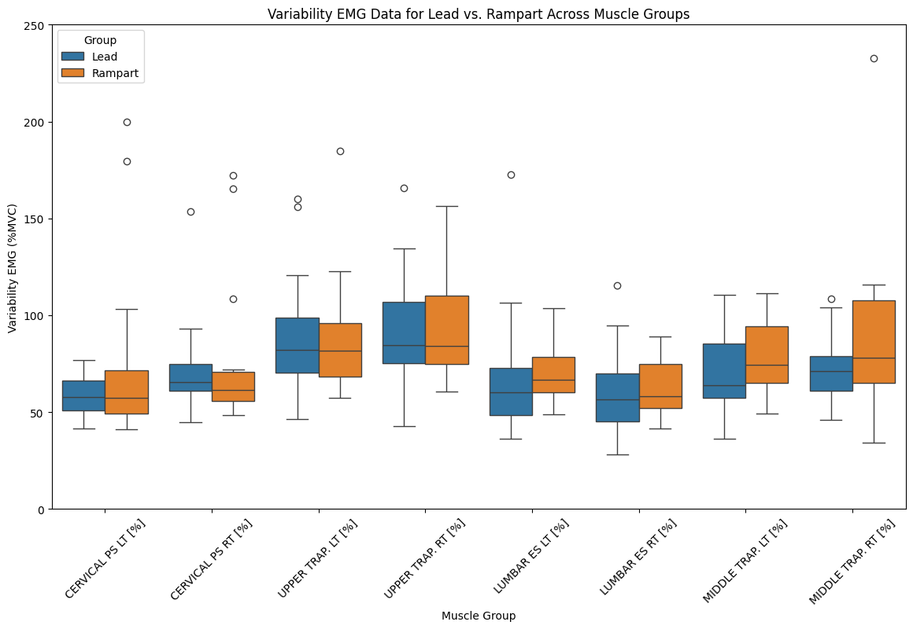
  + 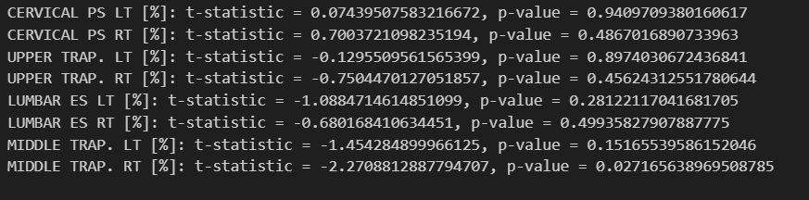
* Stratify by Case Length:
  + 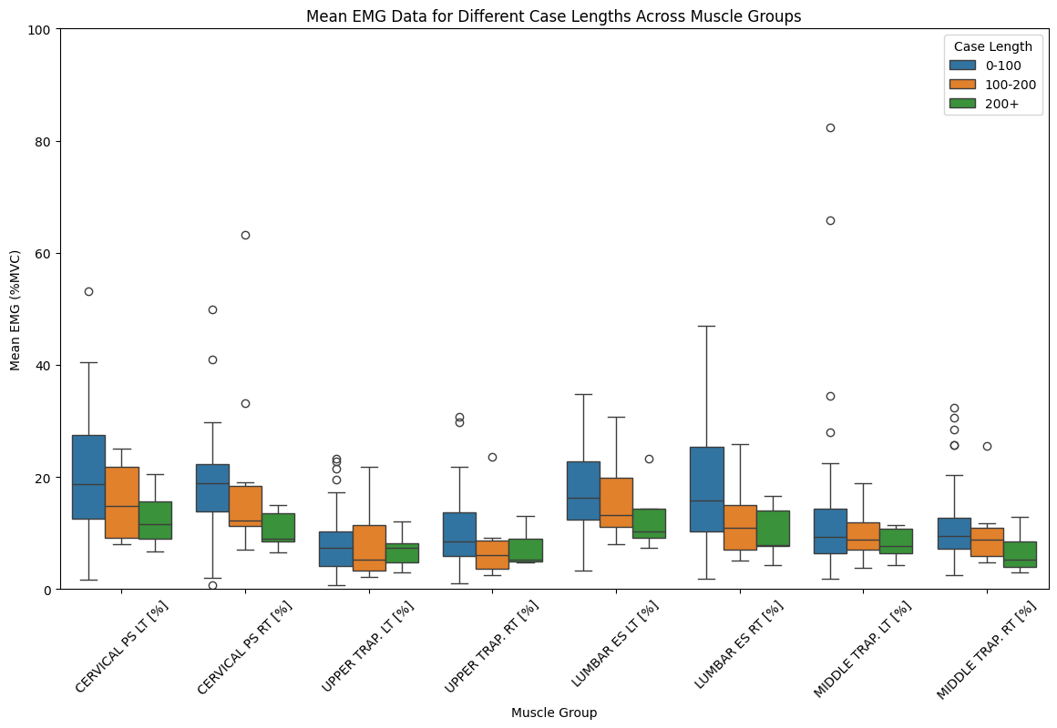
    - No statistically significant instances between these time frames.
  + 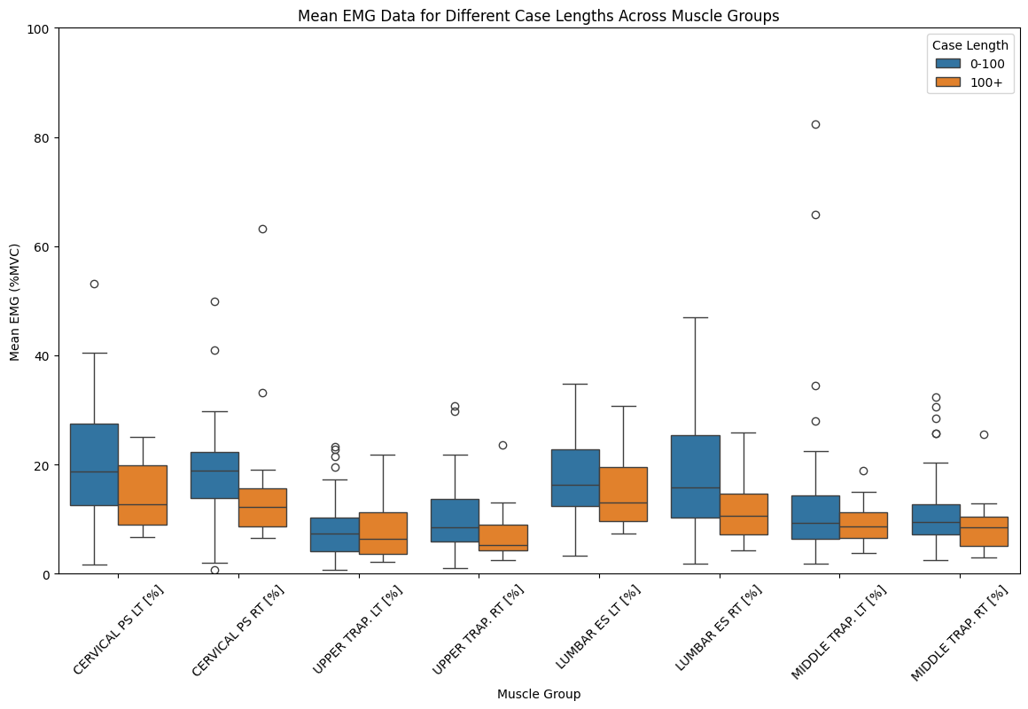
    - 
  + 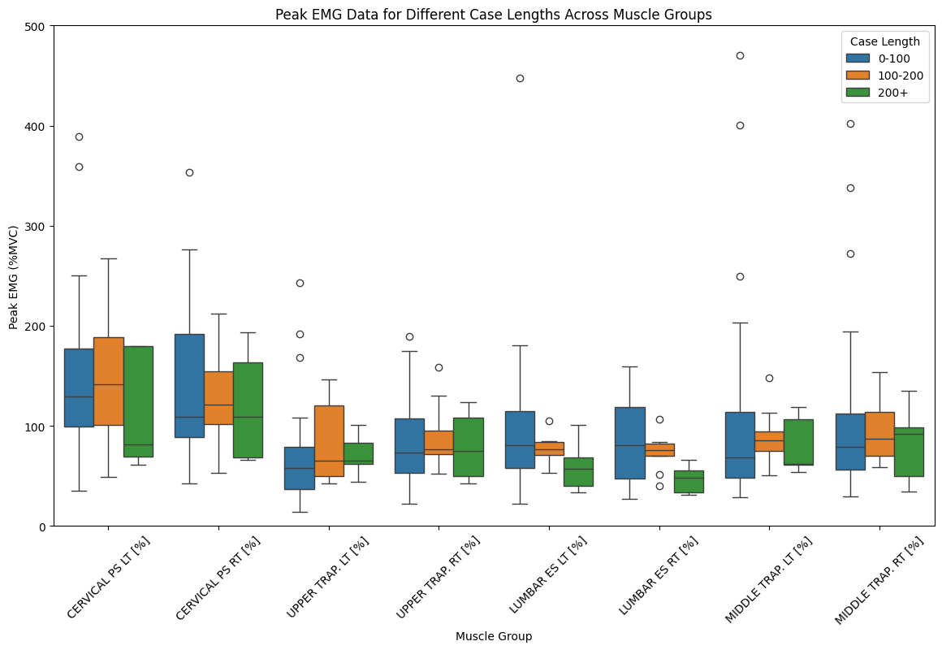
    - No statistically significant instances in these time frames.
  + 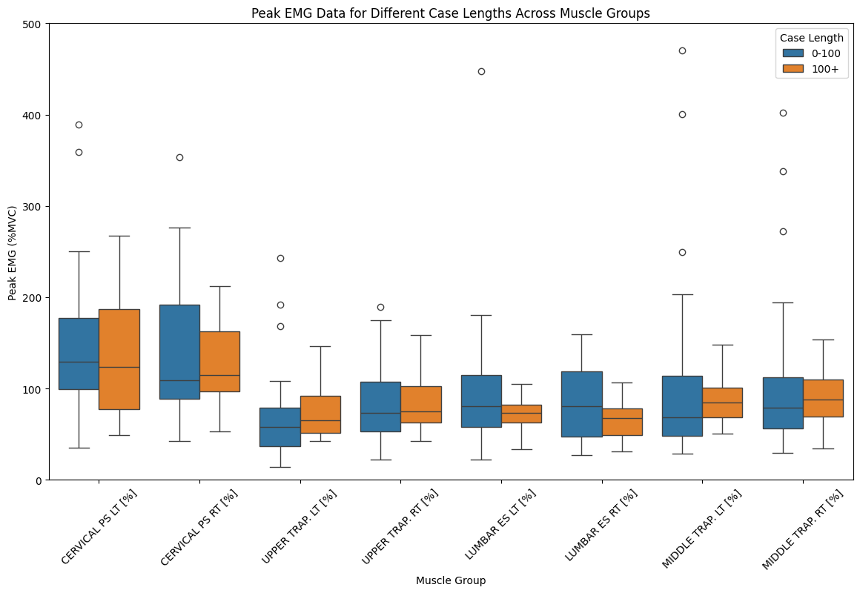
    - 
  + 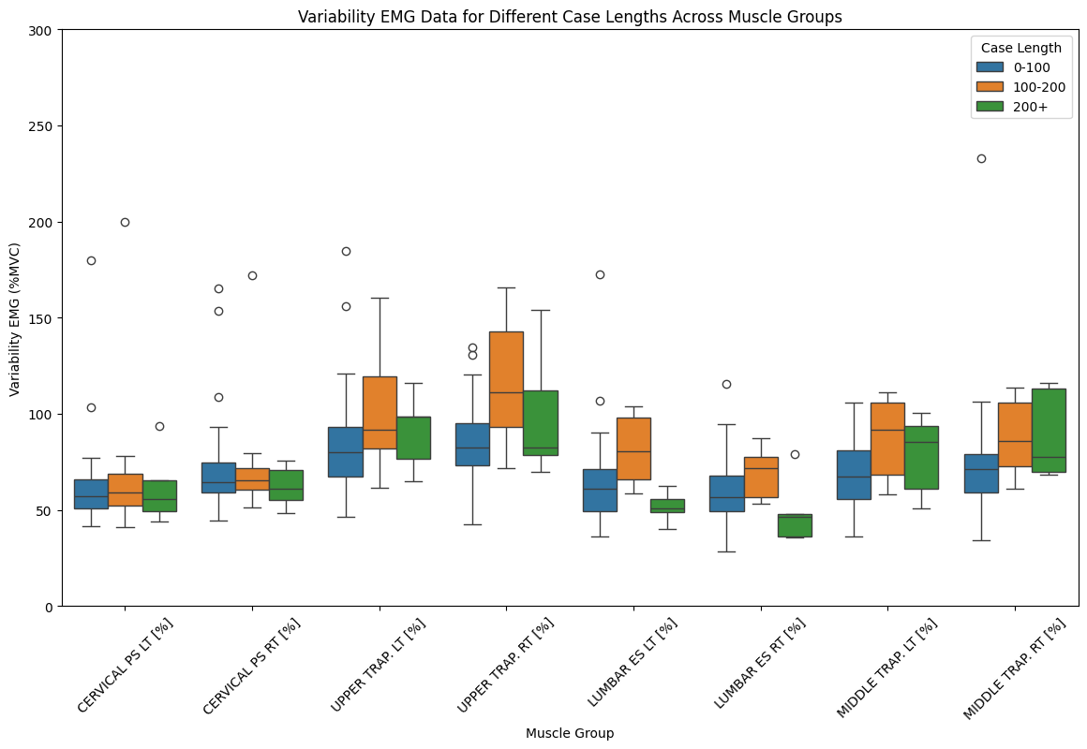
    - No statistically significant instances in these time frames.
  + 
     